Que 1. Create a database university and a collection named students. Insert multiple student document with field: name, age, department, and grades.



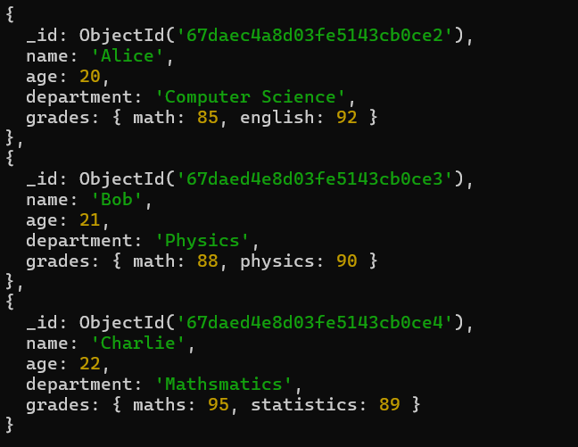

Que 2. Write a query to display all students who are in the Computer Science department.

db.students.find({department:"Computer Science"})

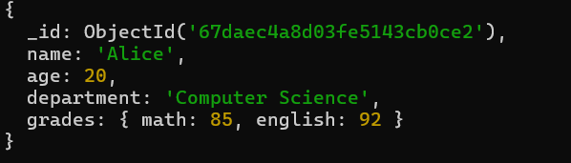

Que 3. Write a query to update the grades of a students named Alice by adding a new subject programming with a grades of 93

db.students.updateOne({name:"Alice"},{$set:{"grades.programming":93}})

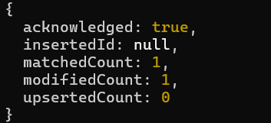

Que 4. Write a query to increment the age of all students by 1.

db.students.updateMany({},{$inc:{age:1}})

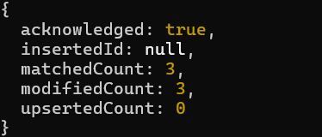

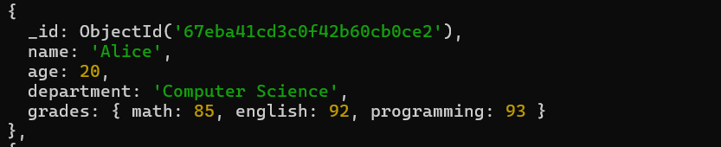

Que 5. Write a query to delete all students who are 23 year old.

db.students.deleteMany({age:23})

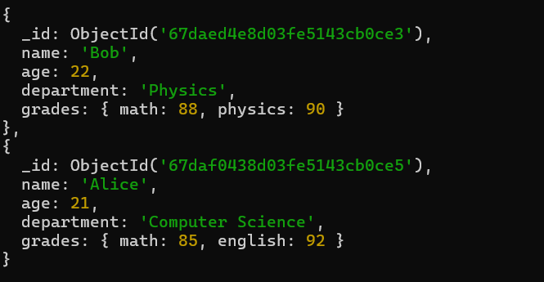

Que 6. Write a query to create a index on the name field of the students collections.

db.students.createIndex({name:1})

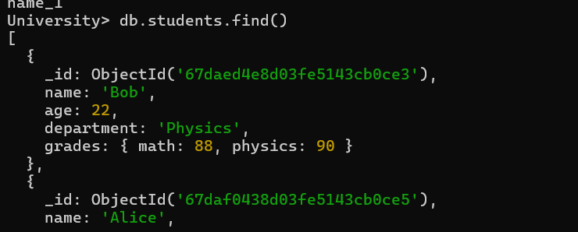

Que 7. Write an aggregation query to group students by their department and calculate the average age in each department.

db.students.aggregate([{$group:{_id: "$department",averageAge:{$avg:"$age"}}}])

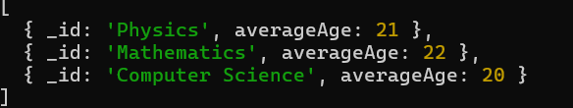

Que 8.  Write a query to find all students who have scored more than 90 in any subject.

db.students.find({$or:[{"grades.math":{$gt:90}},{"grades.english":{$gt:90}},{"grades.programming":{$gt:90}}]})

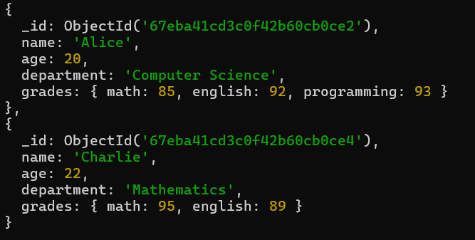

Que 9. Write a query to delete all students who are 23 years old.

db.students.deleteMany({age:{$eq:23}})

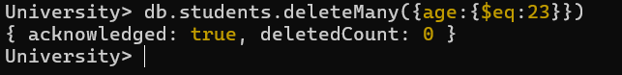

Que 10. How can you retrieve only the name and department fields for all students, excluding the _id field?

db.students.find({},{name:1,department:1,_id:0})

